“The Colt”
By Wallace Stegner
Vocabulary

homestead – a house or estate and the adjoining land, buildings

The drove to his grandparents’ homestead.

draught - the amount of air, smoke, etc, inhaled in one breath
He breathed in a draught of fresh air.

picketed - to fasten or tether to a picket (pole, stake)
He picketed the goat to the fencepost.

haunches - a hindquarter of an animal.
The dog had her tail between her haunches.
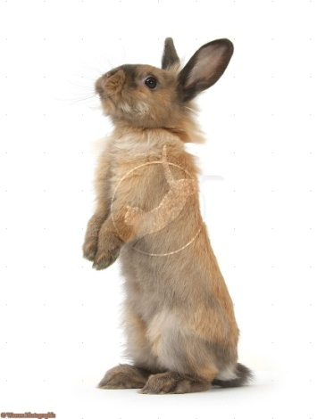

fetlock - a projection behind and above a horse's hoof
The water in the stream was only up to the horse’s fetlocks.
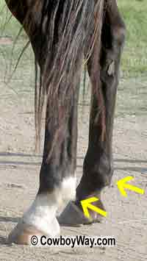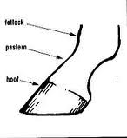
pastern - the part of the foot of a horse, cow, etc., between the fetlock and the hoof.
The bone between the hoof and the first joint is called the pastern.

mongrel - a dog of mixed or indeterminate breed
They wanted a golden retriever, but ended up with a sweet mongrel from the local animal shelter.

mirth - amusement or laughter
Mirth has been proven to improve your health.

superintend - to oversee and direct
He superintended the office building.

